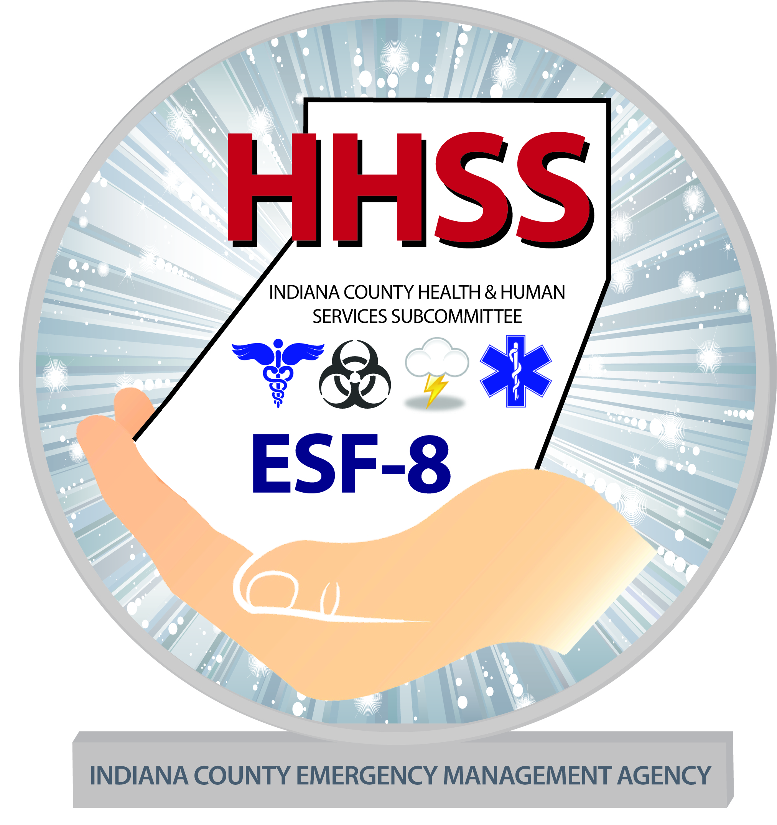

HEALTH & HUMAN SERVICES SUBCOMMITTEE

Address: 300 Indian Springs Rd. Suite 203, Indiana, PA 15701
Phone: 724.463.8200 X8 Fax: 724.465.3159
Email: IndianacountyHHSS32@gmail.com

Your Disaster Supply Kit Should Include:

• AM/FM radio & batteries
• Flashlight & batteries
• Water – one gallon per person per day
• Food – ready to eat or requiring minimal water
• Manual can opener and other cooking supplies and feeding supplies
• First Aid kit & instructions (take a first aid class)
• Personal Prescriptions
• A copy of important documents and phone numbers
• Warm clothes and rain gear for each family member
• Disposable camera (for insurance purposes)
• Unscented liquid household bleach and an eyedropper for water purification
• Personal hygiene items including toilet paper, feminine supplies, hand sanitizer and soap
• Plastic sheeting, duct tape and utility knife
• Tools such as a crowbar, hammer & nails, staple gun, adjustable wrench, bungee cords and heavy work gloves
• Blanket or sleeping bag
• Large heavy-duty plastic bags and a plastic bucket for waste and sanitation
• Any special-needs items for children, seniors or people with disabilities
• Whistle
• Don’t forget water and supplies for your pets
• Keep cash on hand (around $200)
• Know how to turn off your utilities

INDIANA COUNTY DISASTER PLANNING COMMITTEE

