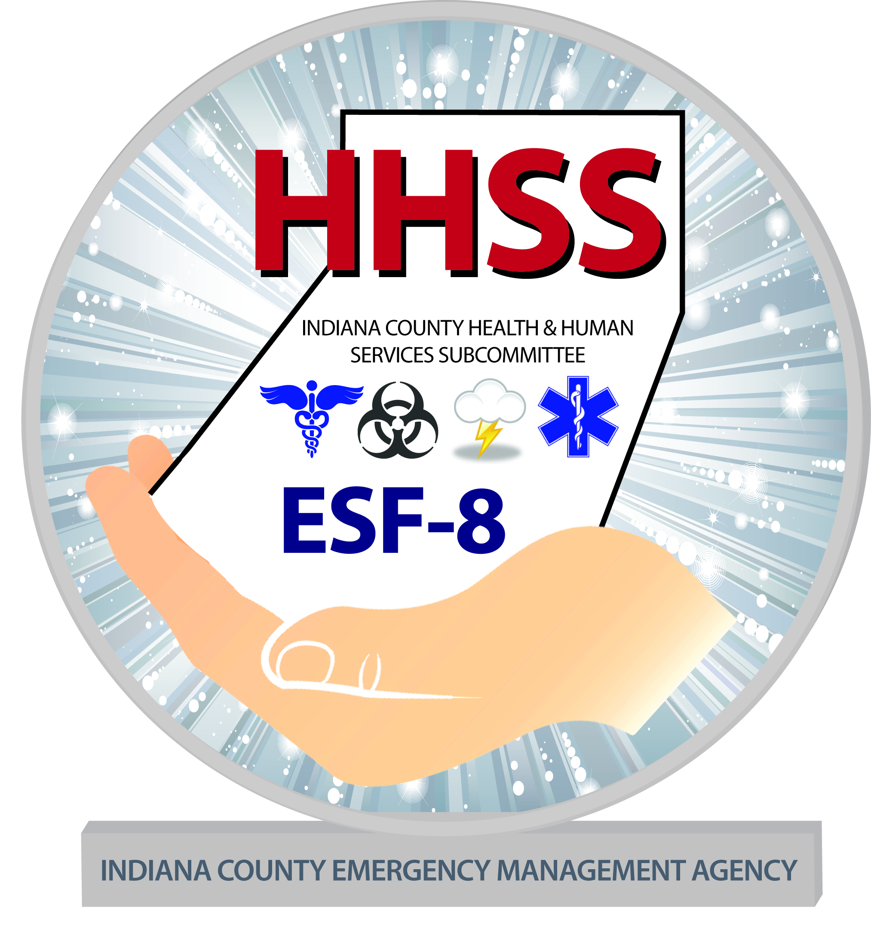

HEALTH & HUMAN SERVICES SUBCOMMITTEE

Address: 300 Indian Springs Rd. Suite 203, Indiana, PA 15701
Phone: 724.463.8200 X8 Fax: 724.465.3159
Email: IndianacountyHHSS32@gmail.com

Preparing Makes Sense for People with Disabilities and Special Needs

Get a kit of Emergency Supplies
The first step is to consider how an emergency might affect your individual needs. Plan to make it on your own, for at least three days. It’s possible that you will not have access to a medical facility or even a drugstore. It is crucial that you and your family think about what kinds of resources you use on a daily basis and what you might do if those resources are limited or not available.
Basic Supplies – Food, water, clean air and any life-sustaining items you require
Medications and Medical Supplies – Be sure you have what you need on hand to make it on your own for at least a week.
Additional Items – Other things specific to your personal needs; eyeglasses, hearing aids, oxygen, wheelchair battery, etc.
Emergency Documents – Copies of important documents; family records, wills, power of attorney, deeds, social security numbers, credit card and bank information, etc. Keep these documents in a waterproof container or bag.

Make a Plan for What You Will Do in an Emergency
Create a Personal Support Network - If you anticipate needing assistance during a disaster, make a list of family, friends and others who will be part of your plan. Talk to these people and ask them to be part of your support network.
Develop a Family Communications Plan - Your family may not be together when disaster strikes, so plan how you will contact one another and review what you will do in different situations.
Deciding to Stay or Go - Depending on your circumstances and the nature of the emergency, the first important decision is whether you stay or go. You should understand and plan for both possibilities
Consider Your Service Animal or Pets - You will need to make plans in advance for your pets and service animals. Keep in mind that what’s best for you is typically what’s best for your animals. Plan in advance for shelter alternatives that will work for both you and your pets.
Staying Put - There may be situations when it’s simply best to stay where you are and avoid any uncertainty outside. Consider what you can do to safely shelter-in-place alone or with friends, family or neighbors.
Evacuation – Plan how you will get away and anticipate where you will go.
Fire Safety – Plan two ways out of every room in case of fire.

Be Informed About What Might Happen
It’s important to stay informed about what might happen and know what types of emergencies are likely to affect your region. For more information about specific types of emergencies, visit www.ready.gov or call 1-800-BE-READY.


INDIANA COUNTY DISASTER PLANNING COMMITTEE

