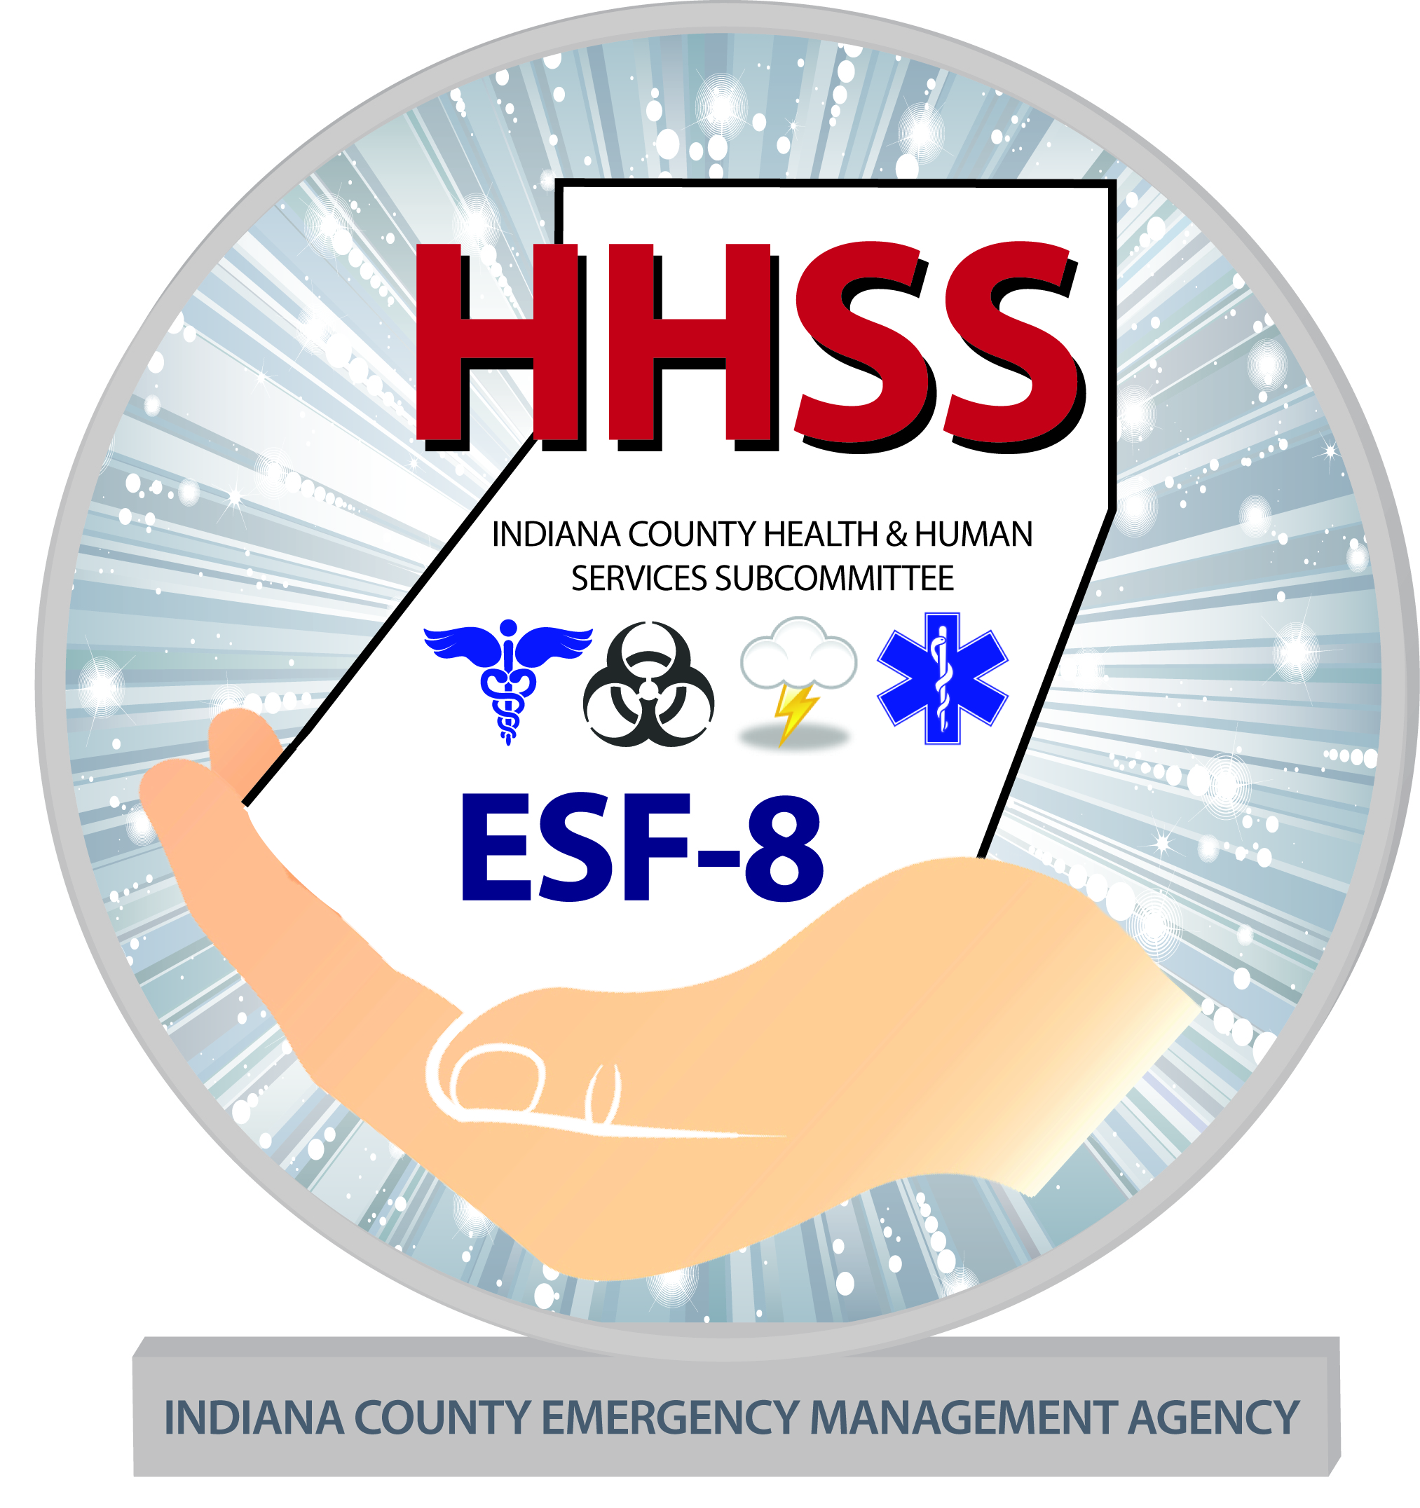

HEALTH & HUMAN SERVICES SUBCOMMITTEE

Address: 300 Indian Springs Rd. Suite 203, Indiana, PA 15701
Phone: 724.463.8200 X8 Fax: 724.465.3159
Email: IndianacountyHHSS32@gmail.com

Preparing Your Pets for Emergencies

- Get a Pet Emergency Supply Kit
Just as you do with your family’s emergency supply kit, think first about the basics for survival, particularly food and water. Consider two kits. In one, put everything you and your pets will need to stay where you are. The other should be a lightweight, smaller version you can take with you if you and your pets have to get away. Plus, be sure to review your kits regularly to ensure that their contents, especially foods and medicines, are fresh.
- Food and Water – At least a 3 day supply
- Medications and Medical Records – Keep an extra supply of medicines your pet takes on a regular basis in a waterproof container
- First Aid Kit - Talk to your veterinarian about what is most appropriate for your pet’s emergency medical needs. Include a pet first aid reference book
- Collar with ID Tag, Harness or Leash - Your pet should wear a collar with its rabies tag and identification at all times.
- Sanitation - Include pet litter and litter box if appropriate, newspapers, paper towels, plastic trash bags and household chlorine bleach to provide for your pet’s sanitation needs.
- A Picture of You and Your Pet Together – In case of separation from your pet, this will act as documentation of ownership and will assist in identification of your pet. Include detailed information about species, breed, age, sex, color and distinguishing characteristics.
- Familiar Items – Familiar items can help reduce stress for your pet.

- Make a Plan for What You Will Do in an Emergency
- Create a Plan to Get Away - Plan how you will assemble your pets and anticipate where you will go.
- Develop a Buddy System - Plan with neighbors, friends or relatives to make sure that someone is available to care for or evacuate your pets if you are unable to do so.
- Talk to Your Pet’s Veterinarian About Emergency Planning
- Gather Contact Information for Emergency Animal Treatment

- Stay Informed About Types of Emergencies
It’s important to stay informed about what might happen and know what types of emergencies are likely to affect your region. For more information about specific types of emergencies, visit www.ready.gov or call 1-800-BE-READY.

INDIANA COUNTY DISASTER PLANNING COMMITTEE

